**BANK LOAN REPORT**

**KPI**

--Total Loan Application

select COUNT(id)as tot_loan_applications from bank_loan_data



-- Month on Month % changes in loan_applications

**-- formula 100 * (current count - previous count) / previous count**

SELECT

month,

loan_applications,

CASE WHEN LAG(loan_applications, 1) OVER (ORDER BY month) IS NOT NULL THEN

100 * (loan_applications - LAG(loan_applications, 1) OVER (ORDER BY month)) / LAG(loan_applications, 1) OVER (ORDER BY month)

ELSE NULL END AS pct_change

FROM (

SELECT

MONTH(issue_date) AS month,

COUNT(id) AS loan_applications

FROM bank_loan_data

GROUP BY MONTH(issue_date)

) AS subquery

ORDER BY month;

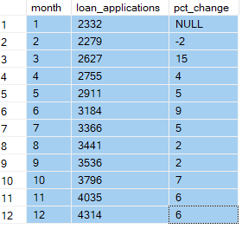

--- Total Funded Amount

select sum(loan_amount) as total_funded_amount from bank_loan_data



-- Get data for latest month

select sum(loan_amount) as MTD_funded_amount from bank_loan_data

where MONTH(issue_date) = 12



-- Month on Month % changes in loan_amount

SELECT

month,

monthly_loan_amount,

CASE WHEN LAG(monthly_loan_amount, 1) OVER (ORDER BY month) IS NOT NULL THEN

100 * (monthly_loan_amount - LAG(monthly_loan_amount, 1) OVER (ORDER BY month)) / LAG(monthly_loan_amount, 1) OVER (ORDER BY month)

ELSE NULL END AS pct_change

FROM (

SELECT

MONTH(issue_date) AS month,

sum(loan_amount) AS monthly_loan_amount

FROM bank_loan_data

GROUP BY MONTH(issue_date)

) AS subquery

ORDER BY month

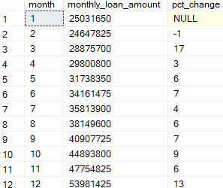

-- Total Recieved Amount

select sum(total_payment)as Total_amount_recieved from bank_loan_data



-- Month on Month % changes in Avg_Int_Rate

SELECT

month,

Total_amount_recieved,

CASE WHEN LAG(Total_amount_recieved, 1) OVER (ORDER BY month) IS NOT NULL THEN

100 * (Total_amount_recieved - LAG(Total_amount_recieved, 1) OVER (ORDER BY month)) / LAG(Total_amount_recieved, 1) OVER (ORDER BY month)

ELSE NULL END AS pct_change

FROM (

SELECT

MONTH(issue_date) AS month,

sum(total_payment)as Total_amount_recieved

FROM bank_loan_data

GROUP BY MONTH(issue_date)

) AS subquery

ORDER BY month;

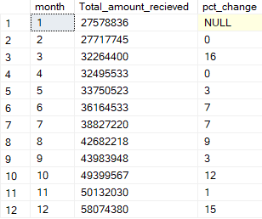

-- Average Interest Rate

select ROUND(AVG(int_rate)*100,2) as Avg_Int_Rate from bank_loan_data



-- Month on Month % changes in Avg_Int_Rate

SELECT

month,

Avg_Int_Rate,

CASE WHEN LAG(Avg_Int_Rate, 1) OVER (ORDER BY month) IS NOT NULL THEN

100 * (Avg_Int_Rate - LAG(Avg_Int_Rate, 1) OVER (ORDER BY month)) / LAG(Avg_Int_Rate, 1) OVER (ORDER BY month)

ELSE NULL END AS pct_change

FROM (

SELECT

MONTH(issue_date) AS month,

ROUND(AVG(int_rate)*100,2) as Avg_Int_Rate

FROM bank_loan_data

GROUP BY MONTH(issue_date)

) AS subquery

ORDER BY month;

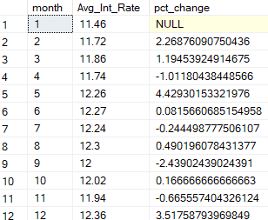

-- Average Debt to income Ratio

select Round(AVG(dti)*100,2) as Avg_dti from bank_loan_data



-- Good Loan Application % (Good loan are Current and Fully Paid)

select

COUNT(Case when loan_status IN('Fully Paid','Current') THEN id END) *100 / COUNT(id) as Good_Loan_percentage

from bank_loan_data



-- Good loan Application

select count(id) as Good_Loan_Applications from bank_loan_data

where loan_status IN ('Fully Paid','Current')



--Good Loan Funded Amount

select sum(loan_amount) as Good_Loan_Funded_Amount from bank_loan_data

where loan_status IN ('Fully Paid','Current')



--Good Loan Total Recieved Amount

select sum(total_payment) as Good_Loan_Recieved_Amount from bank_loan_data

where loan_status IN ('Fully Paid','Current')



**By Dividing** Good Loan Funded Amount with Good Loan Total Recieved Amount **Bank is making profit of** **84.95%**

-- Bad Loan %

select

COUNT(Case when loan_status IN('Charged Off') THEN id END) *100 / COUNT(id) as Good_Loan_percentage

from bank_loan_data



-- Bad Loan Application

select count(id) as Good_Loan_Applications from bank_loan_data

where loan_status IN ('Charged Off')



-- Bad Loan Funded Amount

select sum(loan_amount) as Good_Loan_Funded_Amount from bank_loan_data

where loan_status IN ('Charged Off')



-- Bad Loan Total Recieved Amount

select sum(total_payment) as Good_Loan_Recieved_Amount from bank_loan_data

where loan_status IN ('Charged Off')



**On BAD LOAN Bank is making LOSS of 175.76%**

-- Loan Status Grid View

select loan_status, count(id) as Loan_Applications,

sum(loan_amount) as tot_loan_amt,

sum(total_payment) as tot_amt_paid,

avg(int_rate*100) as avg_int_rate,

avg(dti *100) as dti

from bank_loan_data

group by loan_status

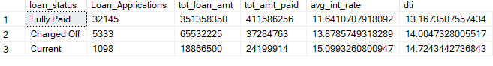

-- Monthly Trends by Issue Date

select MONTH(issue_date)as Month_Number,

DATENAME(month, issue_date) as month,

count(id) as Loan_Applications,

sum(loan_amount) as tot_loan_amt,

sum(total_payment) as tot_amt_paid

from bank_loan_data

group by DATENAME(month, issue_date),MONTH(issue_date)

order by MONTH(issue_date)

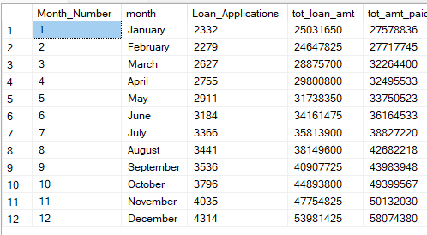

-- Regional Analysis by State

select address_state,

count(id) as Loan_Applications,

sum(loan_amount) as tot_loan_amt,

sum(total_payment) as tot_amt_paid

from bank_loan_data group by address_state order by address_state

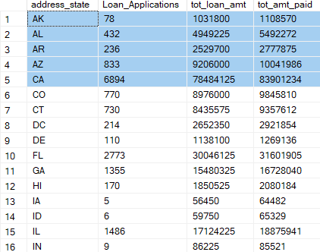

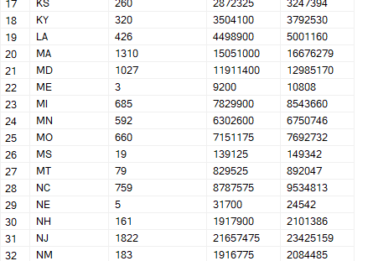

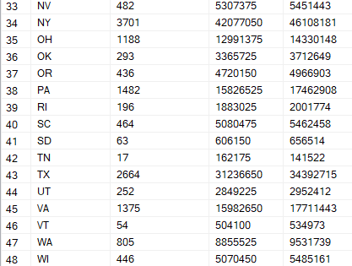



-- Loan Term Analysis

select term,count(id) as Loan_Applications,

sum(loan_amount) as tot_loan_amt,

sum(total_payment) as tot_amt_paid

from bank_loan_data group by term order by term



-- Employee Length Analysis

select emp_length,

count(id) as Loan_Applications,

sum(loan_amount) as tot_loan_amt,

sum(total_payment) as tot_amt_paid

from bank_loan_data

group by emp_length

order by tot_loan_amt

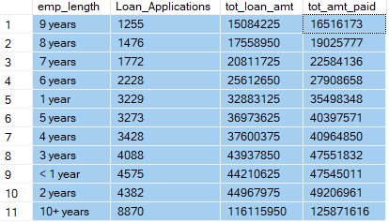

-- Loan Purpose Breakdown

select purpose,

count(id) as Loan_Applications,

sum(loan_amount) as tot_loan_amt,

sum(total_payment) as tot_amt_paid

from bank_loan_data

group by purpose

order by tot_loan_amt DESC

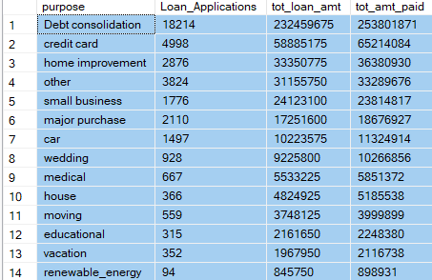

-- Home Ownership Analysis

select home_ownership,

count(id) as Loan_Applications,

sum(loan_amount) as tot_loan_amt,

sum(total_payment) as tot_amt_paid

from bank_loan_data

group by home_ownership

order by tot_loan_amt DESC

